I have done some work before I got the idea of making a log, so I’ll start by telling of what has happened thus far:

I started out by designing the engine of my rocket. I am probably going to use hydrogen gas as fuel, as it is plentiful on this planet, but I still needed to figure out specifics like how hot I needed the gas to be, how much I would bring, how big I would need to make the engine and the like.

As is well known, every action has an equal and opposite reaction (or overreaction, Greg, I didn’t mean to spill that coffee on you and you know it), so if I throw enough stuff out of my engine, I should be able to blast myself towards God, wherever he is.

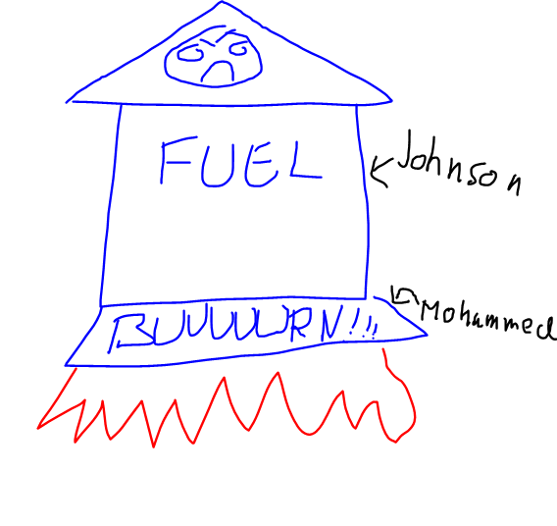The engine needs one large tank to hold all the hydrogen, and then a separate part to burn it in. Normally these are called the fuel tank and combustion chamber, but I’m going to name mine Johnson and Mohammed, because Johnson you are a fat fuck, and Mohammed you really need to fucking take down your temper. I’m almost glad you left me here. Anyways, when you heat up a gas it expands, and when you burn hydrogen it expands a fuckton more. So when I burn the hydrogen in the Mohammed room, it’s pushed out the bottom and then, because Newton says so in his fancy three rules, my rocket will be pushed in the opposite direction, hopefully away from this stupid planet. Naturally, I also refuel the Mohammed room with hydrogen from Johnson because otherwise, Mohammed would run out of fuel and my rocket wouldn’t work. I try to keep the refuel the same as the amount of fuel I’m pushing out, so that there’s a constant amount of fuel in the room, and I have a constant push and I won’t have to be jiggled around during my entire trip.

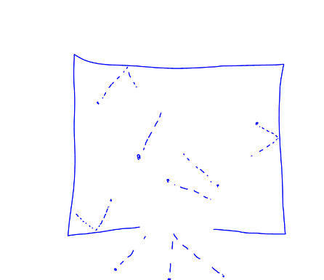So to find out how hot I need to burn the fuel, I made a simulation of how the particles would move if I gave them certain temperatures, certain densities, etc., etc. I use the Python coding language to first put all the particles in random locations inside a very small box (way too small to be fitting of the name Mohammed room, but I’ll fix that later, it’s only a simulation), and gave them a certain temperature to see how fast they moves, and how much they pushed against the walls. Then I made a tiny hole in one of the walls and saw how many particles flew out, in which case I put another one in with the same velocity as the one that escaped (ok, technically I just bounced it back into the box instead of letting it escape, but when you deal with very large amounts of particles in a simulation, that kind of error becomes very very small).   
I used this to find out how much the box pushed and was now ready to do the thing that would simulate an actual engine. I simulated a big box with lots of fuel (that’s you, Johnson), and attached a bunch of the small boxes at the bottom to simulate a proper Mohammed (Yes Mohammed, you are a stuck up bitch and you should really take some anger management courses).

Now I had all I needed to simulate takeoff. I activated the engine, with the fuel, and saw the simulation take off… And crash right back into the ground. After a couple of trials and many failures, I found a combination of fuel amount, chamber sizes and temperatures to finally get a liftoff that wouldn’t kill me with acceleration.

That’s about all I have done so far, next I want to see how the solar system moves and simulate it ahead of time so that when I launch myself off here, I won’t end up in cold space where a planet used to be.

From a more technical standpoint, I can talk about what I did in a bit more detailed way. I will try to keep this part more formal, since this is the part I will probably have to refer to in order to find out what I did wrong.

When I first tried to simulate the particles in the box, I tried to check each individual particles velocity and distance from a wall, and then skip the calculations until that point, but the way it turned out I couldn’t make the code satisfyingly tidy (I lost oversight several times), and chose to redo it. What I chose to do was to do was write down the positions and velocities of all the particles into tables and then simulate their motion and make a new table each time they moved. Afterwards I could use the table to easily extract information without having to integrate any new methods into my initial code. The particles hitting the wall could present a problem, because using a computer you have to use approximations and steps of time, so that in a timestep a particles could have gone outside the box without the computer noticing, and would then have to calculate where it would have gone instead. To fix this problem, I decided to check for any particles that made it outside and then shift them inwards towards the box by the distance of the box, in a way making the sides of the boxes teleports that lead to eachother. This only works because I was using a very large amount of particles, so that even if it was weird that a particle suddenly moved like that, there was a *very* high possibility that another particle was doing something of opposite weirdness, cancelling eachother out. This also meant that the velocities never changed, so I could use the same velocity table over and over

156 147

I also had to make a hole in the box, and calculate the momentum of the particles escaping to find out how much the box would push if I made it into a combustion chamber. Since I had a large table with that contained the information of all the times any particle made it outside, I could just check all the ones that escaped *through* the hole and check their velocities in my velocity table, and voila! I had my momentum loss. Because momentum is always conserved, I used that to find out how much a box would accelerate a given satellite put on top of it

Now all I had to do was plug a bunch of my boxes together, assign them a mass to push in the form of fuel and a satellite(where I would sit), and try numbers until I managed to lift off and hit escape velocity. This step was fairly simple, I just had to try a lot of times to get the right combination of boxes, temperature, fuel, combustion density (the amount of particles inside the combustion chamber at any one time), box size and the size of the hole in each combustion box. Eventually I made it work and simulated in 19 minutes.